**List of Essential Components & Tools for Learning Electronics at Home**

**By TSJ_Electronics (TSJelectronics.com)**

**Where to buy this stuff:**

1. Aliexpress.com   
   For cheap bulk components like resistors, LED’s, Capacitors, Transistors, Microcontrollers, & Microcontroller Modules. You can find good assorted component packs here but look carefully at shipping price. Sometimes a 3.00 component pack has 5.00 shipping.
2. Amazon.com  
   For quick shipping components, starter kits, and assorted component packs. (assorted resistor kits, assorted leds, assorted capacitors etc.)
3. Digikey.com and Mouser.com   
   These are great places to buy high quality components for later on in your electronics journey.

**Books:**

1. Make: Electronics  
   By Charles Platt
2. Encyclopedia of Electronic Components Volumes 1,2, & 3  
   By Charles Platt
3. Practical Electronics For Inventors  
   By Paul Scherz & Simon Monk
4. The Art of Electronics  
   By Paul Horowitz & Winifield Hill

**Tools:**

(The included images are for reference, not my suggested buy. Shop around and find the right tool at the right price for YOU).

1. Multimeter  
   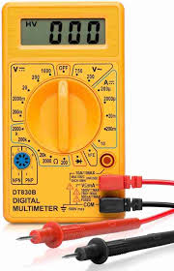
2. Wire Strippers  
   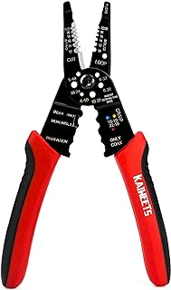
3. Wire Cutters  
   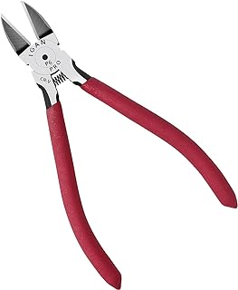
4. Needle Nose Pliers  
   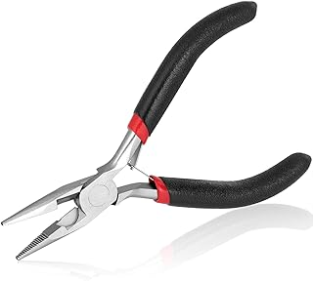

**Basic Components:**

(The included images are for reference, not my suggested buy. Shop around and find the right tool at the right price for YOU).

1. Breadboards:  
   Breadboards come in different sizes noted by how many connection points on the board. Get a full size 830 Poins breadboard for starting off. I recommend getting a pack of 2 – 4. Having extras is always nice.  
   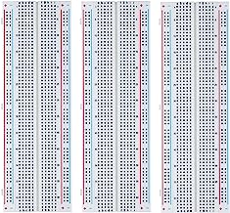
2. Resistors:   
   Get a ¼ Watt Resistor Assortment. Resistors come in different power ratings which affects there size and shape. For breadboarding 1/4w is the standard.  
   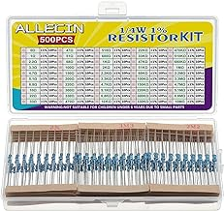
3. Potentiometers:  
   Potentiometers are variable resistors. As you turn the knob left or right the resistance of the component increases or decreases. I recommend getting a few different values of potentiometers from 1k Ohms to 100k Ohms.  
   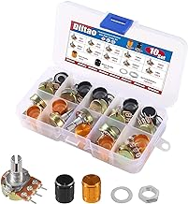
4. LED’s:  
   Breadboarding LED’s come in 3mm and 5mm sizes. I suggest getting the 3mm size, I just like them better. So get an assorted pack of 3mm or 5mm LED’s.  
   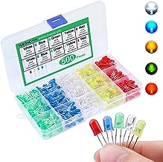
5. Power Supply:  
   To power our circuits I recommend a 9v battery and 9v battery connector. 9 volts are ideal for beginners because they are safe and have relatively low discharge current meaning your less likely to destroy them or burn your breadboard and components.   
   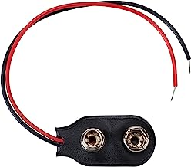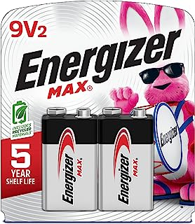
6. Jumper Wires:  
   Jumper wires are used to create connections between components.  
   They come in male to male, male to female, and female to female varieties. For breadboarding your mostly going to use male to male connections but it doesn’t hurt to have a few of each.  
   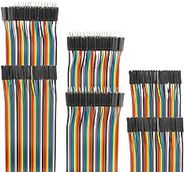
7. Capacitors:  
   Capacitors hold a small amount of charge that is measured in farads. and are used for timing circuits, filter circuits, smoothing power supplies, and debouncing. There are two types of capacitors I suggest for breadboarding, ceramic capacitors & electrolytic capacitors. Grab yourself an assorted capacitor kit. Your kit should contain ceramic capacitors that contain pico farad, and nano farad values. Also you need electrolytic capacitors that that range in value from 1 micro farad to 100 micro farads. The ceramic capacitors are the orange ones, the electrolytic are the black / silver ones that look like tin cans.  
   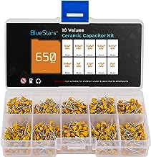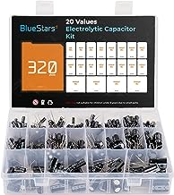
8. (BJT) Transistors:  
   Bipolar Junction Transistors come in two basic types – PNP and NPN transistors. You can grab an assorted box of transistors that will contain both types, or you can buy some 2N2222a NPN Transistors, and some 2N2907 or 2N3904 PNP Transistors.  
   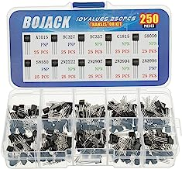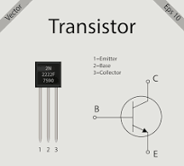
9. Diodes:  
   Diodes are components that allow the flow of current in one direction, and block the flow of current in the other direction. You can pick up a pack of assorted diodes but really all you need is some 1n4007 diodes.  
   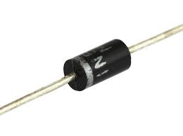
10. Tactile Switches (Pushbuttons):  
    Tactile switches, also called momentary push buttons allow us to control circuits, at the push of a button! Grab yourself an assorted pack of the 6mm x 6mm variety.  
    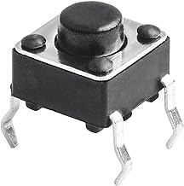
11. Micro Slide Switches:  
    Slide switches come in a few different varieties, but you want SPDT, that stands for single pole double throw. These switches provide 3 points of connection and allow us to switch between two different circuits or provide on / off functions.  
    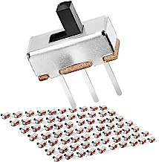
12. Buzzers:  
    Buzzers are used for making noise. They come in active buzzers, which have built in drivers so all that is needed is applied DC current and they will make noise. There are also passive buzzers, which can play multiple tones by applying varying frequencies of wave forms. (the active and passive buzzers are nearly identical, get something that looks like the image below)  
    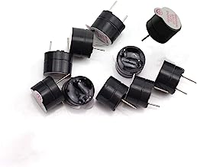
13. 7 Segment Display  
    7 Segment Displays are used for displaying standard decimal numbers. They come in many shapes and sizes. For breadboarding my personal favorite is the Common Cathode (CC) Single Digit 0.56 inch Display.  
    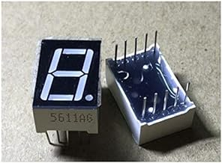

**Basic Integrated Circuits (IC’s):**

1. 555 Timer
2. CD4026 or CD4033
3. CD4017
4. Arduino Style Microcontroller (The Arduino Uno is very popular)

Of course as you learn your collection of components will grow. You will eventually need the 74HCXX Logic series for learning digital logic, multiplexers, etc. You will need to learn OP amps for audio and waveform circuits, and so much more. This page was just intended to point users in the right direction. These are just my suggestions, and I strongly encourage you to buy the first book listed as that is a more comprehensive resource on these topics.

Thank you and have fun making with electronics 😊